* 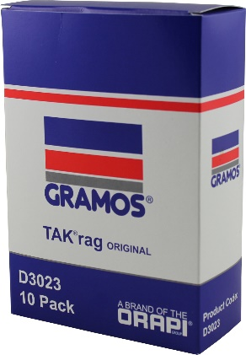 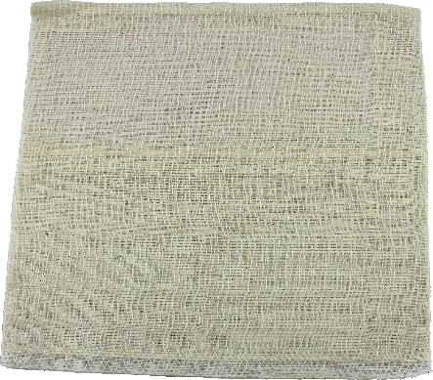

**Woven Cotton TAK®rags**

* 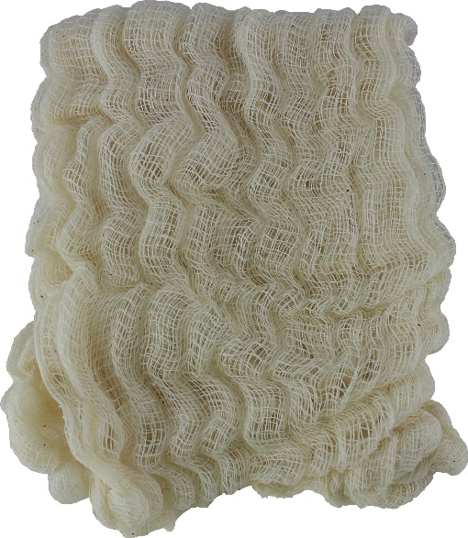

**Woven Cotton TAK®rags**

**maxaTAK®**

* 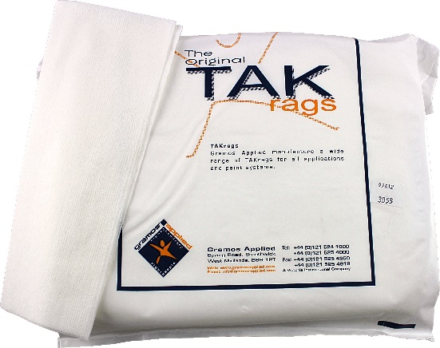

**Non Woven TAK®rags**

**Ultra TAK®**

* 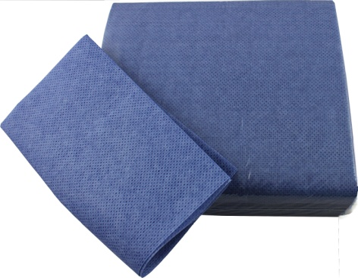

**Woven Cotton TAK®rags**

**aqua****TAK®**

* 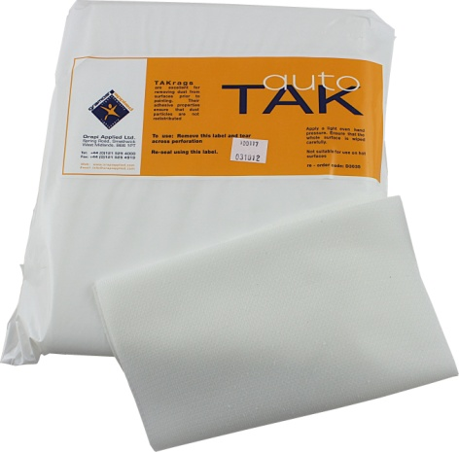

**Knitted Polyester TAK®rags**

**autoTAK®**

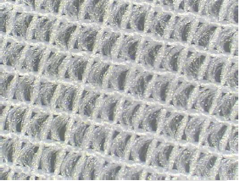

Continuous Filament Knitted Polyester

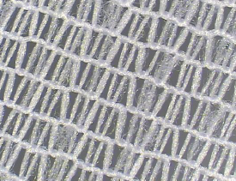

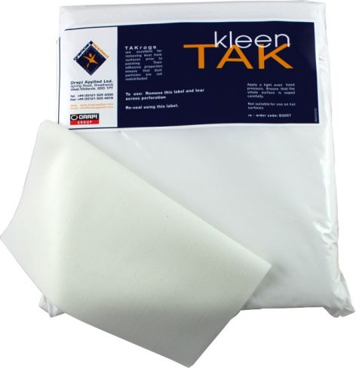

**Knitted Polyester TAK®rags**

**KleenTAK®**

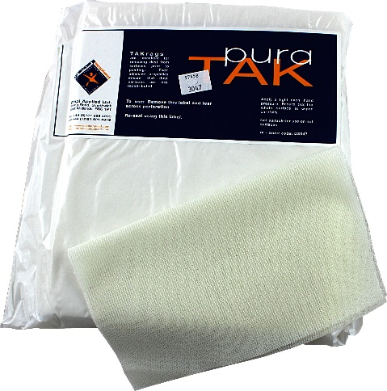

**Knitted Polyester TAK®rags**

**puraTAK®**